GAYAZA JUNIOR SCHOOL
MATHEMATICS P.2
- Order the sets using ordinal numbers


_____ _____ _____ _____

- Make new sets and name them

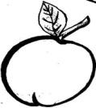
____________
_____

_________________

_________________
- Compare the sets
P E


Set P has ____________________ members
Set E has ____________________ members
Set P has _____________ members than set E
Set E has _____________ members than set P

- Add these sets



______ + _______ = _______



______ + ______ = _______

- Subtract these sets



- =

_____ – ______ = ______

m
- h a - =

______ – _______ _______

- Draw these sets
- A set of 3 cats

- A set of 1 car

- A set of 5 letters

- Name these sets


______________________________

- _______________________________

- Add
- 3 kgs + 5 kgs = __________

- 2 7 kgs
+ 1 2 kgs

- Eight kilograms plus two kilograms equals
__________ kilograms .

- Subtract
- 10 kgs – 7 kgs =

- 8 6 kgs
- 5 4 kgs

- Five kilograms minus three kilograms equals ___________ kilograms .

- Peter is 12 kgs
Jane is 10 kgs

- Who is lighter ?
____________________________________________

- Who is heavier ?
_____________________________________________

- Find their total weight .

- Find the missing numbers

- 6, 7, ____ , _____

- 11, 22, 33, ____ , ____

- 100 , 101, 103, ____ , ____

- 993, 994, ____ , ____

- 221, 231, ____ , ____

- Complete the table

+ | 1 | 2 | 3 | 4 | 5
1 | 2 | __ | 4 | __ | __
2 | 3 | 4 | __ | 6 | __
3 | 4 | __ | 6 | __ | __
4 | 5 | __ | __ | __ | 9
5 | __ | 7 | __ | 9 | __

- Circle the bigger number
- 8 or 28 (c) 18 or 34
- 12 or 02 (d) 24 or 83
- Circle the smaller number
- 100 or 18 (c) 17 or 79
- 88 or 18 (d) 39 or 99

- Work out
- 8 + 1 = ____

0 1 2 3 4 5 6 7 8 9 10

- 2 + 3 + 4 = _____

0 1 2 3 4 5 6 7 8 9 10

- 10 – 9 = _____

0 1 2 3 4 5 6 7 8 9 10

- 7 – 5 = ____

0 1 2 3 4 5 6 7 8 9 10

- (1) Study the graph and answer the questions

Mary Jane Cathy Eva

- Who two girls got the same number of books ?
_____________________________________________
- Who has the highest number of books ?
_____________________________________________
- How many books did Mary and Eva get ?
______________________________________________
- How many books were got by all the girls
(2)

P.1 P.2 P.3
(a) Which class has the lowest number of pencils?
______________________________________________
(b) How many pencils did P.1 and P.3 get?
__________________________________________________
(c) How many pencils did all the classes get altogether?
___________________________________________________

- Add
- 8 litres + 7 litres

- 4 2 litres
+ 1 7 litres

- Four litres plus three litres equals ________ litres

Subtract

- 12 litres – 6 litres = __________________

- 9 8 litres
- 6 3 litres

- Thirteen litres take away nine litres equals __________________ litres

What is the time?

12 12
11 1 11 1
10 2 10 2
9 3 9 3
- 8 4 8 4
7 5 7 5
6 6

It is _________ O’clock It is ________ O’clock

- Draw and show the correct time
It is 1 O’clock

- (a) Fill in the missing days.
Monday, Tuesday, _________________________ ________________ , __________________ , Saturday,_________________________

(b) Write the months of the year correctly.
(i) nuaryJa ________________________
(ii) chMar ____________ (iii) rilAp _____________
- What is the last month of the year ?
____________________________________________
- How many days make a week ?
- Add
- 2 + 8 = _______ (e) T O
7 8
- 3 + 2 + 4 = ____ + 2 0

- 4 (d) T O (f) H T O
2 4 3 9 2 5
+ 2 + 1 + 0 6 3

- (a) Nine plus four equals _________________
(b) Kasuku has 15 books. Kasule has 13 books.
How many books do they have altogether ?

(c) 5 apples
+ 2 apples

- Take away
- 12 – 8 = __________ (d) T O
8 2
- 6 0

- 7 (c) 3
- 2 – 3

(e) Ten pencils take away three pencils.

(f) Elizabeth had 11 sweets. She gave away
7 sweets to her sister. How many sweets did
she remain with ?
- (a) Shade the given fractions

= 2
4

(b) = 5
7
- Find the place values of the circled
number
- 2 2

- 3 6 1

- 4 0 4

- Write in words.
- 11 ____________________________________
- 100 ___________________________________
- 29 ____________________________________
- 8 ____________________________________

- Expand the following numbers
- 6 7 3

- 2 9 5

- 4 1 3

- What number has been expanded ?
- 900 + 50 + 4 = _______________

- 300 + 30 + 3 = _______________

- Find out the missing numbers
- 2, 4, _____, 8, _____, 12

- + 7 = 10

- + 2 = 8

- 1 + = 6

- 5 – = 2

- Show the working and complete the tables

(a)
10 3
x 2
5 6

(b)

4
7 5
11–
8 9

7 4 + 4
5

- Read and fill in
Six _______ eight ______ ten ______

- Use heavier, taller, lighter and shorter

A
B

- Stone A is _________________ than stone B
- Stone B is _________________ than stone A
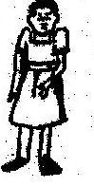
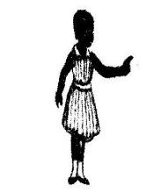

Cissy Christine

- Christine is _____________ than Cissy.

- Cissy is _________________ than Christine.

- Work out:

3 m + 2 m = _______

1 m m cm
4 m 2 4
+ 5 m + 3 1

8 m – 2 m = _______

m cm
9 3
– 6 1



GJS – ENGLISH FOR P.2
Spell and read the given words
grandfather uncle son grandmother aunt daughter brother sister mother father.

- Write these words correctly.
utna _____________ erthom _______________
ons ______________ audghert ______________
Write the sentence about each given word.
- grandmother
______________________________________________
- father
______________________________________________
- sister
______________________________________________
- uncle
______________________________________________
- Read the story and answer the questions that follow in full sentences.

Amulen’s Family
Amulen and her family live in Kiyunga village. They are six members; father, mother, Amulen, two brothers and uncle Omondi. All the members of Amulen’s family are hardworking. Father and uncle Omondi work in a shop and they buy things needed at home. Mother cooks food and the children wash utensils, clean the house and the compound

Questions
- Write the title of the story.
_______________________________________________
- Whose family is talked about ?
_______________________________________________
- Where do the people in the story live ?
_______________________________________________
- How many children are in the story ?
_______________________________________________
- What is the name of Amulen’s uncle ?
_______________________________________________
- With whom does Amulen’s uncle work ?
_______________________________________________
- Write two activities done by Amulen and her brothers.
- __________________________________________
- __________________________________________
- What work does mother do ?
_______________________________________________
- How many members are in Amulen’s family ?
_______________________________________________

Spell and read the words
Numbers with words
1 – one 2 – two 3 – three 4 – four 5 – five 6 – six
7 – seven 8 – eight 9 – nine
10 – ten 11 – eleven 12 – twelve
13 – thirteen 14 – fourteen 15 – fifteen
16 – sixteen 17 – seventeen 18 – eighteen
19 – nineteen 20 – twenty 30 – thirty
40 – forty 50 – fifty 60 – sixty
70 – seventy 80 – eighty 90 – ninety
100 – one hundred.

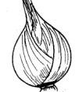
Count and write the number in words
- _________________onions.

- ________________triangles.

___________ pencils.

Read and draw
- Four boys are playing football.

- Six tins are on the table.

- Seven cats are in front of the classrooms

- There are eleven trees at the side of the road.

Answer these questions
- How many sisters do you have?
_______________________________________________
- How many brothers do you have?
_______________________________________________
- How many uncles have you?
_______________________________________________
- How many aunts do you have?
_______________________________________________

Spell and read these words.
nurse doctor shopkeeper teacher
butcher builder carpenter policewoman
farmer patient driver

Use the given words to complete the sentences.
- A _________________________ treats patients.
- A _______________________enforces law and order.
- A _______________________ sells things in a shop.
- A ______________________ drives cars.
- A _________________________ sells meat.
- A _________________________ teaches children.
- A _________________________ makes furniture.
- A _________________________ builds houses.

- Read the dialogue and answer the questions that follow in full sentences.

Amooti: Good morning Akiiki.
Akiiki: Good morning Amooti
Amooti: Who are the people in your community?
Akiiki: We have doctors, teachers, butchers
and many others
Amooti: That’s good. What work do they do?
Akiiki: Doctors treat patients.
Carpenters make furniture.
Builders build houses.
Teachers teach children.
Butchers sell meat.
Amooti: It’s a lively community.
Questions
- At what time did the dialogue take place ?
The dialogue took place in the _______________
- Who was the first speaker ?
_______________________________________________

- Write two people in Akiiki’s community.
- _____________________________________
- _____________________________________

- What do doctors do ?
_______________________________________________
- What do carpenters do ?
_______________________________________________
- What do builders do ?
_______________________________________________
- Who teach children ?
_______________________________________________
- Do people in Akiiki’s community eat meat ?
_______ the people in Akiiki’s community eat meat.

- How many people were speaking ?
_______________________________________________
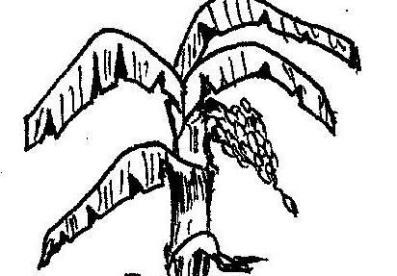
- Study the picture and answer the questions.
A Farmer
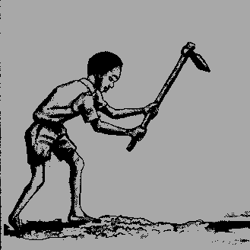

Questions
- Who do you see in the picture ?
I see a ______________________ in the picture.
- What is he holding ?
______________________________________________
- What is he doing ?
______________________________________________
- Where is he?
______________________________________________

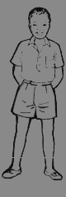
28. Name the parts of the body.

Answer the questions below;
- How many fingers do you have?
______________________________________________
- How many toes do you have?
______________________________________________
- How many eyes do you have?
______________________________________________
- How many ears do you have?
______________________________________________
- How many heads do you have?
______________________________________________

Re-write the sentences as instructed.
- Nieces are girls. Nephews are boys. (use ….… while …….)
____________________________________________________
- We respect our father. He heads the family. (use : …… because …….)
____________________________________________________
- He treated my sick sister. He is a doctor.
(use: …….. because ……...)
____________________________________________________
- That is the teacher. She teaches us English.
(use: ………… who ………..)
____________________________________________________
- A nurse works in a hospital. A doctor works in a hospital. (use: ……….. and …………)
____________________________________________________

- One by one makes a ________________________ (complete the proverb)

- This is my eye. It got hurt. (Use; …. Which ….)
____________________________________________________
- That is the farm. My father works there. (use; ….where …..)
____________________________________________________
- The teacher went to the classroom. The children were not there. (use; ………. but ………..)
____________________________________________________
- My mother is cooking food. (End: ….. yesterday)
____________________________________________________
- Tom is thin. He is strong. (Use; …… but …….)
___________________________________________________
- Thieves stole the car. I was sleeping. (Use … when …)
________________________________________________
- The reverend is preaching. The Imam is preaching. (Begin: Both …………………)
____________________________________________________
- This is my sister. (Begin: These ……….)
____________________________________________________
Write a sentence about each of these words
- mouth: _________________________________________
- ear: ___________________________________________
- hair ___________________________________________
Spell and read these words
collect brush burn cook mop boil throw wash slash sweep cover smoke dustbin rubbish pit clean

- Fill in the missing letters to complete the words.
br__sh c__ __k swe__ __ cl__ __n s__ __ sh sm__ke c__v__r
Fill in the spaces using the given words to complete the story
sweeping, slashes, clean, collect, house, compound, evening, burn, rubbish bin, rubbish pit

My mother always wants us to keep our home __________. She buys brooms for ______________the ___________________ and the ____________________. She tells us to mop the house every morning and ____________________ . She tells us to throw rubbish in the ___________________ and when it gets full, we pour it in the __________________ and ___________________ it. When grass over grows around the house, our father _____________ it and we _____________ it with a rake . This can help us prevent diseases.

LITERACY I FOR P.2
Food and Nutrition
- What is food _________________________________
________________________________________________
- Name these foods eaten at home.
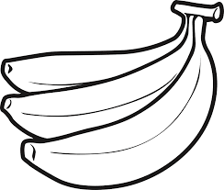
_______________ 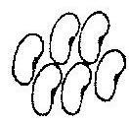 ______________

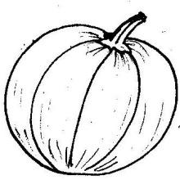
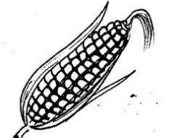
_____________ __________________
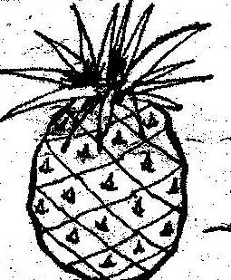

___________________________

- Mention any two reasons why people eat food.
- __________________________________________
- __________________________________________
- Name the main sources of food;
- ______________________________________
- ______________________________________
- Where do people in villages commonly get their food from?
_______________________________________________
- Write any two places where people in town buy their food.
(i) _____________________________
(ii) _____________________________

- Tick four foods got from plants.
Chicken, pawpaw, bananas, pork, rice, pumpkin, yoghurt
- Name any two foods got from animals
- __________________ (ii) __________________

- State any two products got from milk.
- _________________ (ii) ___________________
- Name these classes of food.
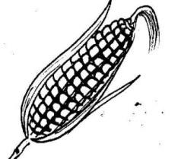
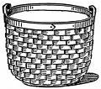

- Millet matooke maize

________________________________________

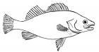
- fish beans fresh
dairy
__________________________________________

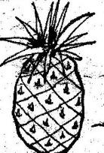
- Pineapple tomatoes
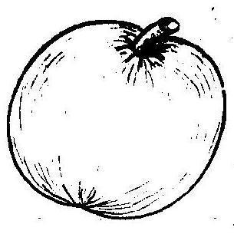
Water melon

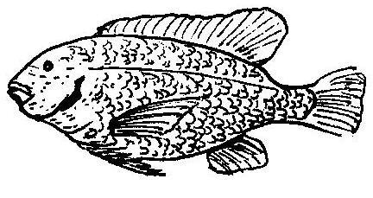
- Study the diagram below and answer the questions that follow.

- Name that animal eaten at home __________
- Where does it live?
____________________________________________
- How does it move?
____________________________________________
- Name its young one.
____________________________________________
- Which food value do we get from eating that animal?
____________________________________________
- Food hygiene is the way of keeping our food clean.

- How can we keep our food clean?
- _____________________________________
- ________________________________
- ______________________________________
- How does food become dirty?
Give any two ways.
- ______________________________________
- ______________________________________

- Underline the dangers of eating dirty food.
We get diseases
We become happy
We can vomit
We become healthy.

- Food preservation is the way of keeping food for a longer time without going bad.

- Give any three ways of keeping food for a long time or ways of preserving food.
- ______________________________________
- ______________________________________
- ______________________________________

- Write one way of preserving groundnuts.
____________________________________________
- Name any two foods that can be preserved by smoking.

- ______________ (ii) _________________
- Write out vegetables from the list below.
Cabbages pork
rice sukumawiki
carrots fish
- __________________ (iii) __________________
- ___________________

- Circle the food that provides proteins.
meat millet rice beans milk

Our environment
Environment are people and their surroundings. The main components of the environment are;
- Living things
- Non–living things.
- What are living things
________________________________________________
- State the two main groups of living things.
- ___________________________________
- ___________________________________

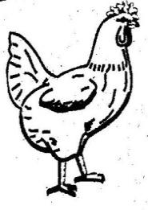
- Name these examples of living things.
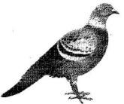
_______________________
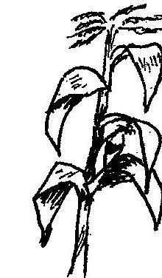
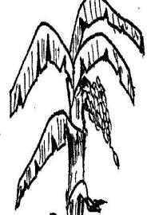
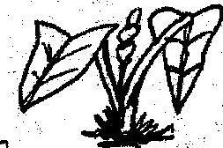
_______________________

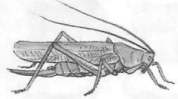
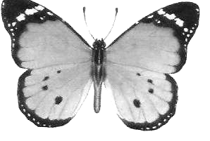
_______________________

- Write any three things which living things can do . (i) _______________________________________
(ii) _______________________________________
(iii) ________________________________________
- Why is a bird a living thing?
________________________________________________
- What are non-living things?
________________________________________________

- Give any two examples of non-living things.
- __________________ (ii) __________________
- Why is a chair a non-living thing?
________________________________________________
- What are domestic animals?
________________________________________________
- Name any two domestic animals.
- __________________ (ii) __________________
- Why do people keep cows?
_______________________________________________
- To which group of animals are goats?
________________________________________________
- What do we call the animals that live on their own?
________________________________________________
- Write any two dangerous wild animals
- ________________ (ii) ________________

- Why do animals move from one place to another ? Give two reasons.
- __________________________________________
- __________________________________________
- How are animals dangerous ?
________________________________________________
- How can we care for animals?
________________________________________________
- Give any two animals that live in water.
- __________________ (ii) ___________________
- Match animals to their sounds.
A monkey bleats
A sheep chatters
A pig trumpets
An elephant grunts
A lion cries
A baby roars

- Complete the table correctly.
Animal | Movement
A snake  ___________________  A bird  ___________________  A fish  __________________ | wriggles  ______________________  crawls  _____________________  hops

21.Match animals to their weapons
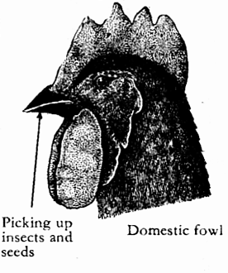

A snake

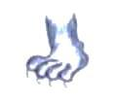

A cow

A cock

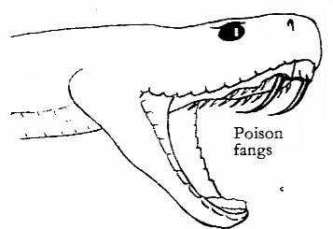
A cat

Common birds
- What name is given to birds kept at home?

- Write any two domestic birds.
- __________________ (ii) ___________________

- Name any two wild birds.
- __________________ (ii) __________________

- State any two products got from birds.
- __________________ (ii) __________________

- Match birds to their young ones.
duck eaglet
hen duckling
eagle owlet
owl chick

- Study the picture below and answer the questions correctly.
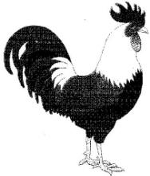

- Name that bird.
_________________________________________
- How does it move?
_____________________________________________
- Name its weapon.
______________________________________________
- To which group of birds does it belong?
______________________________________________
- Which part helps it to fly?
_______________________________________________

Common insects
- Name any two useful insects
- __________________ (ii) _________________

- Apart from wasps, write any other harmful insect. _________________________

- How many legs has a true insect?
________________________________________________
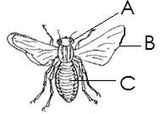
- Name the parts of an insect below.

D D

A _________________ C _________________
B _________________ D ________________

- How is part B useful to an insect?
________________________________________________
- Name the insects that can be found in people’s hair. ________________________________

- To which part of an insect are legs and wings attached ?
________________________________________________

Common plants

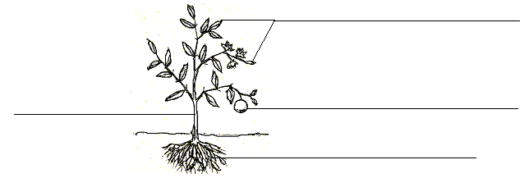
- Name the parts of a flowering plant below.
a

b
e c
d
a _____________________ c _____________________
b _____________________ d _____________________
e _____________________
- Give any two ways of caring for plants
- _________________________________________
- _________________________________________

- Name the parts of a plant eaten from the following plants;
- bananas ____________________________
- cassava ____________________________
- sugarcane ____________________________
- cabbage ____________________________

- How useful are trees to people?
________________________________________________

- Name any two seeds that are eaten.
- __________________ (ii) _________________
- What do we call the plants that bear flowers?
________________________________________________

- Draw these plants.
banana plant | mango plant

Accidents and Safety
- What do we call a sudden happening that can cause injury or death?
______________________________________________
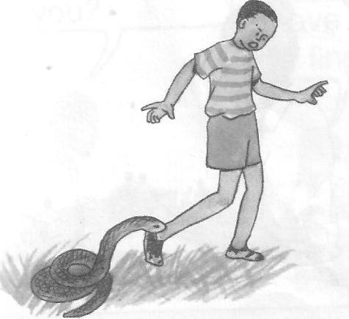
- Name these common accidents.

____________________________

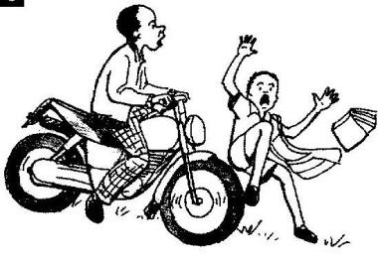
_____________________________
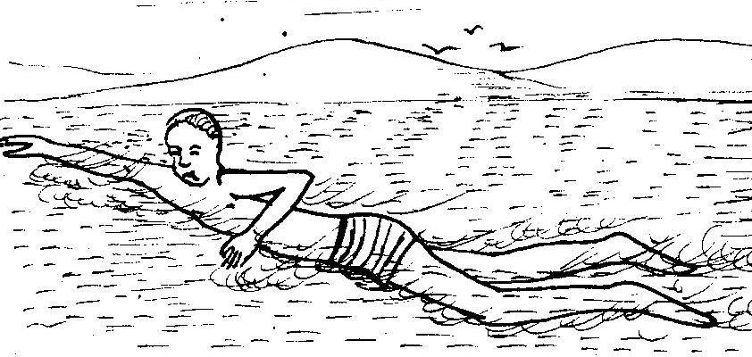
___________________________
- State any two causes of common accidents.
- ________________________________________
- ________________________________________

- Give any two ways of controlling common accidents.
- ________________________________________
- ________________________________________
- Why is it bad to play near water bodies?
______________________________________________
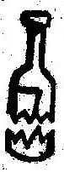
- Name these dangerous objects.


__________________________________

_______________________________
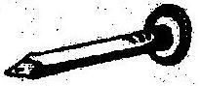
________________________________
- Why is it bad to climb trees?
______________________________________________
- What do we call the first help given to an injured person before being taken to hospital?
______________________________________________
- Why should we give First Aid?
- ________________________________________
- ________________________________________
- Give any two things found in the First Aid box.
- ________________________________________
- ________________________________________
- Name any one place where a First Aid box
can be found. ________________________________
- Underline three effects of accidents.
death lameness
love good relationship
poverty
Weather
- What is weather?
_______________________________________________
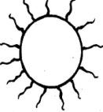
- Name these types of weather.
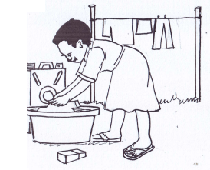

_______________________________________________

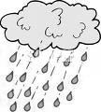

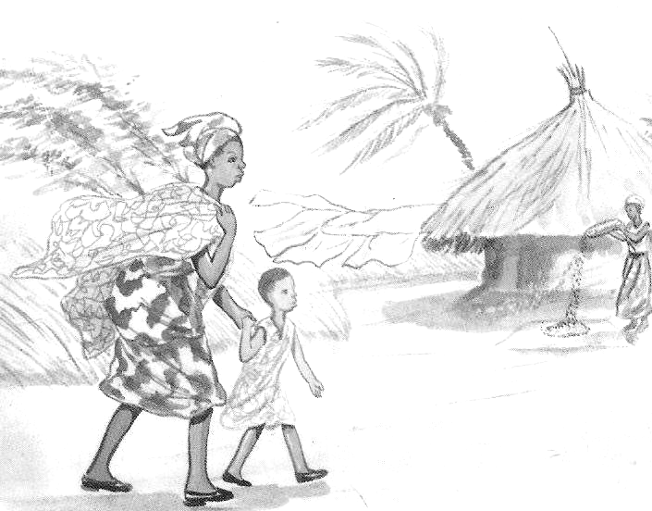

_______________________________________________

- Why do you put on a sweater during cold weather? _____________________________________
________________________________________________
- Why do people put on light clothes during hot or sunny weather? _______________________
________________________________________________
- Which element of weather helps a farmer to dry seeds? ___________________________________
________________________________________________
- Which vitamin do we get from the sun?
________________________________________________
- Name the main source of water.
________________________________________________

- Why does a farmer need rainy water?
________________________________________________
- During which weather do people use rain coats?
________________________________________________
- Write any two places where rain water goes.
________________________________________________
- Which element of weather makes the soil soft for digging?
________________________________________________
- Apart from wet season, write any other type of season.
________________________________________________

- Write any two activities done during the season that you have named in number 12.
________________________________________________

- Match the activities done during wet season to their meanings.

Weeding removing excess plants
from the garden
Thinning removing unwanted
plants from the garden
Harvesting removing excess
Branches
Pruning removing ready crops
From the garden

- How are the following garden tools useful to a farmer?
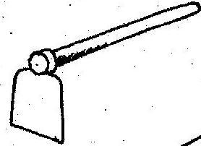
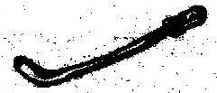
_________________________________________________

_____________________________

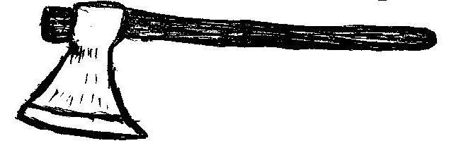

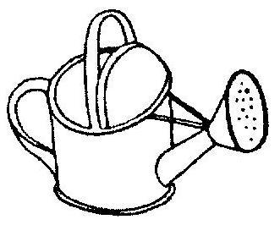
________________________________________________

_______________________________________________

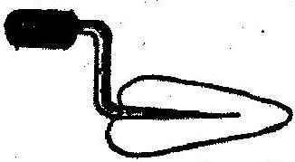

________________________________________________
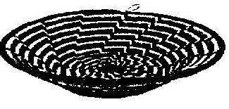

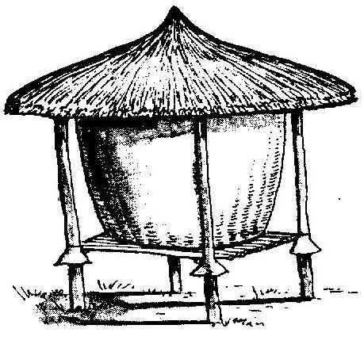
- Study the diagram below and answer the questions about it.

- Name that structure.

- How is it useful to a farmer?

- Write any four foods that can be kept in that structure.

- ______________________________
- ______________________________
- ______________________________
- ______________________________

LITERACY II FOR P.2
Things we make
- What do we call things we make out of local materials using hands?
________________________________________________
- Name these things we make

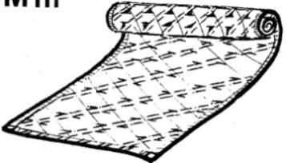
______________________________


______________________________
- ______________________________
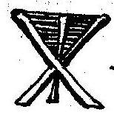
______________________________

- Write any three materials we use to make crafts.
- ______________________________
- ______________________________
- ______________________________

- Name any two products made out of the following;
- banana fibres
- _________________ (ii) __________________
- clay
- _________________ (ii) __________________
- papyrus
(i) __________________ (ii) __________________
(d) palm leaves
- __________________ (ii) __________________
(e) wool
- ________________ (ii) _________________

(f) sisal
- _________________ (ii) __________________
(g) raffia
- _________________ (ii) __________________

- Write out the sources of materials used to make crafts from the list below.
swamp, clay, forest, sticks, bush, papyrus,
seeds, gardens.
- ___________________ (iii) _________________
- __________________ (iv) ___________________

- Write true or false
- A carpenter makes things out of banana fibres. __________________________
- A potter makes things out clay. _____________
- A welder makes things out of metal. ________
- Craftsmen make things out of local materials. _________________
- A tailor makes things out of iron. ___________

- How are crafts useful ? Give two ways.
- ____________________________________________
- ____________________________________________

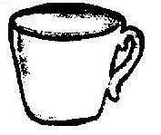
- The diagram below is an example of a craft.

- Name that craft.
_____________________________________________
- How is it useful to people?
_____________________________________________
- Name the local material from which it is made. ________________________________
- Identify one place where it can be found.
______________________________________________
- How can it be kept clean?
_____________________________________________

- Match the materials to their sources correctly.
Palm leaves forest
Banana fibres factory
Wood swamp
Clay palm tree
Wires sisal plant
Sisal banana plant

Transport and Communication
- What is transport ?
_________________________________________________
- Name any two types of transport
- ___________________________________________
- ___________________________________________
- Name the fastest means of transport.
________________________________________________
- Which is the commonest type of transport ?
________________________________________________
- Of the four types of transport, which one is the most expensive?
________________________________________________
- Draw and name any two means of water transport.

- Apart from a donkey name any other two animals used for transport.
- ___________________ (ii) ___________________
- Who is a pilot?
__________________________________________________
- What do we call a person who sails a ship?
________________________________________________
- Where do aeroplanes land and take off?
__________________________________________________
- Complete correctly by using the words in the
brackets.
(passengers, riders, cyclists, pedestrians)

- People who walk alongside the road on foot are called _____________________________

- People travel by bus, taxi or aeroplanes are called _________________________________

- People who ride bicycles are called __________________________

- Write one problem people meet when using roads. _____________________________________

- Write one safe way of using the road.
__________________________________________________
- Name these road signs.

P ____________________________

___________________________
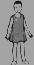

_____________________________

____________________________

- Which road sign helps pedestrians to cross a busy road?
- Identify one group of people who help us to use the road safely. ____________________________
- Name any one road accident.
________________________________________________
- Write any one cause of road accident that can be brought by school children.
__________________________________________________
- Apart from that cause, write other two causes of road accidents.
- ____________________________________________
- ____________________________________________
- How can drivers prevent road accidents? Give any two ways.
- ____________________________________________
- ____________________________________________

- Mention any two dangerous things found on the roads. (i) _________________________________
(ii) _________________________________
- Name these means of communication.
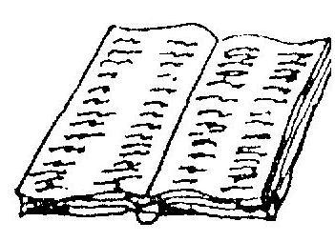
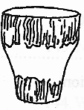
Bukedde

_______________________ _____________________
PEACE AND SECURITY.
Peace is living in harmony with others.
Security is living under protection and freedom.
- Write any three people who promote peace and security in our community.
- ________________________________________
- ________________________________________
- ________________________________________
- How can we promote peace and security at school? Give two ways.
- __________________________________________
- __________________________________________
- Fill in the missing letters.
- pe__ ce (d) sp__ __ r
- secu__ __ ty (e) ba__ __ n
- fr__ __dom (f) resp__ __ting
- Which group of people enforce law and order?
________________________________________
- Name these things used to keep peace and security.

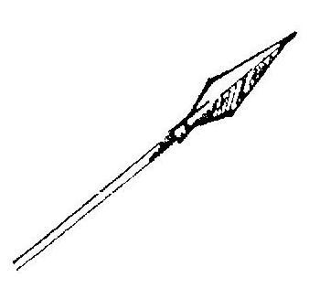 | 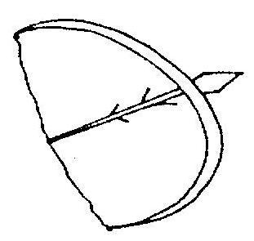 | 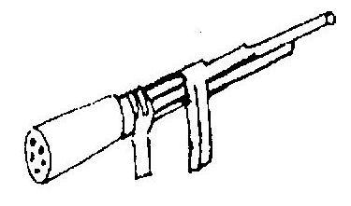

- Tick the people who cause insecurity.
kidnappers
parents
murderers
famine
death
thieves

